Guidance for Topic 3 DQ 1
- As always, don’t forget to enter your name in C2.

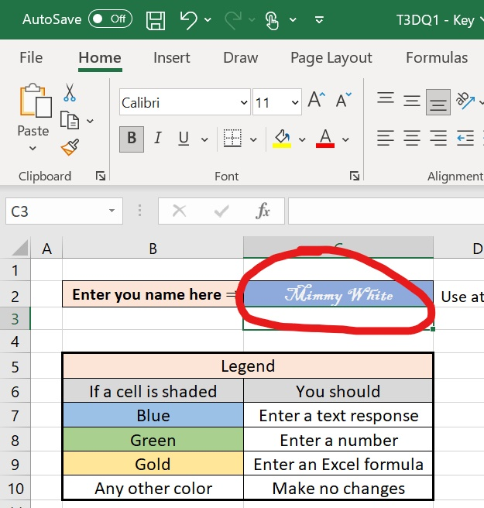

- Once you enter your name, you will see four personalized problems.

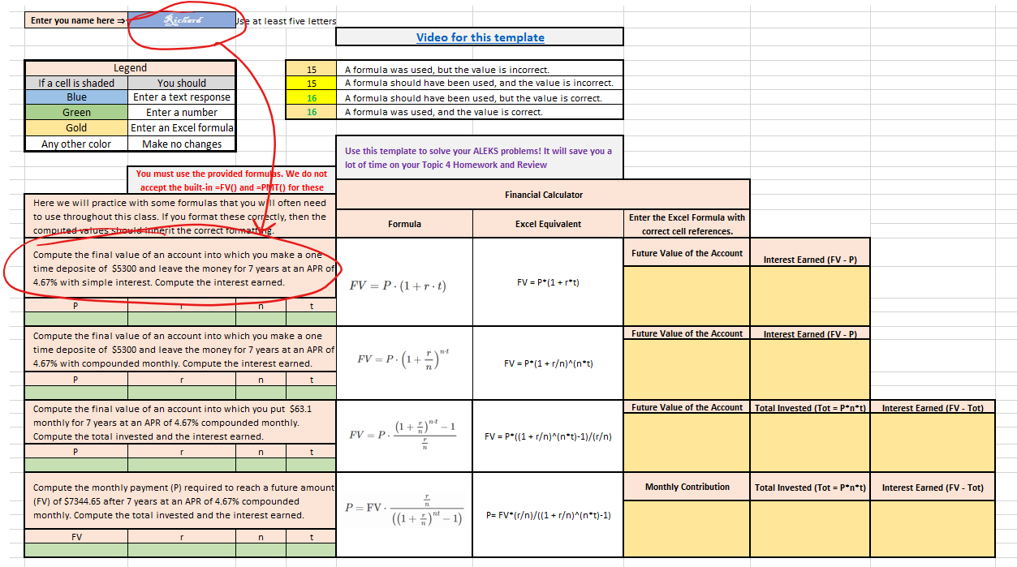

- I show one example here. Copy the values from your problem into P, r, t, and n. The formatting has been set for you. Notice that you must enter formulas, not just values, and that if correct, the sheet will indicate this.

